## Meeting Notes

Dec 4:

Meet bullet points:

1. Setting up goal timeline
2. Compiling google form for research

Goal Before next meeting:

1. Check the questionnaire forms and start thinking about getting responses from the “blind” and the “deaf”

Dec 6:

Meeting with Amazon Mentor:

1. Q: how do you like the idea?
   1. It’s a good idea.
2. Q: research helps:
   1. For the people with disables:
      1. <https://webaim.org/resources/>
      2. <https://dscout.com/people-nerds/user-research-resource-roundup>
   2. how to recruit people with disabilities
      1. <https://www.userinterviews.com/blog/recruit-people-with-disabilities-accessible-uxr>
      2. <https://www.nngroup.com/articles/guide-ux-research-methods/>
      3. <https://www.nngroup.com/search/?q=accessibility+research>
   3. Actual research on people: subtitles and dubes
   4. Form specific suggestions:
      1. Dependency questions
      2. Clear vague and unclearness

Dec 13:

Meeting with Amazon Mentor:

Questions bullets:

Suggestions :

1. Narrow down the scope
2. how would the submission be like? What would the presentation be like?
3. Would the Figma board look good on the presentation?
4. What would the grading be like
5. What is your research approach?
6. Ask for email and linkedin!
7. 1 on 1 interview??

Overall

1. Elevator pitching

Goal before next meeting:

1. Looking for people
2. Background
3. Google slide ->
4. Gathering resource

Dec 18: 6:00-8:00

1. catch up
2. Role division
3. Figma instruction

## Interview & Answers

### Dubbed – Tanya

1. **How often do you watch videos on Prime video with dubbed audio? (On a scale of one to ten with ten being all the time)?**

7, I often like to watch international shows with English dub.

1. **Would you prefer having a filter to help you search for media with your preferred audio language?**

Yes

1. **Does dubbed audio enhance your viewing experience on Prime Video?**

Yes

1. **How would you rate the ease of changing audio on Prime Video? (Please rate on a scale of one to ten with ten being easy to access)**

I would say about 7. It’s not too hard but gets a little annoying having to click through so many buttons after turning on a movie or show.

1. **On a scale of 1-10, how helpful would saving dubbed audio preferences to your profile be? This would give you the ability to have all your content be filtered throughout the app to your preferences. You can have the ability to set how filtered the content should be.**

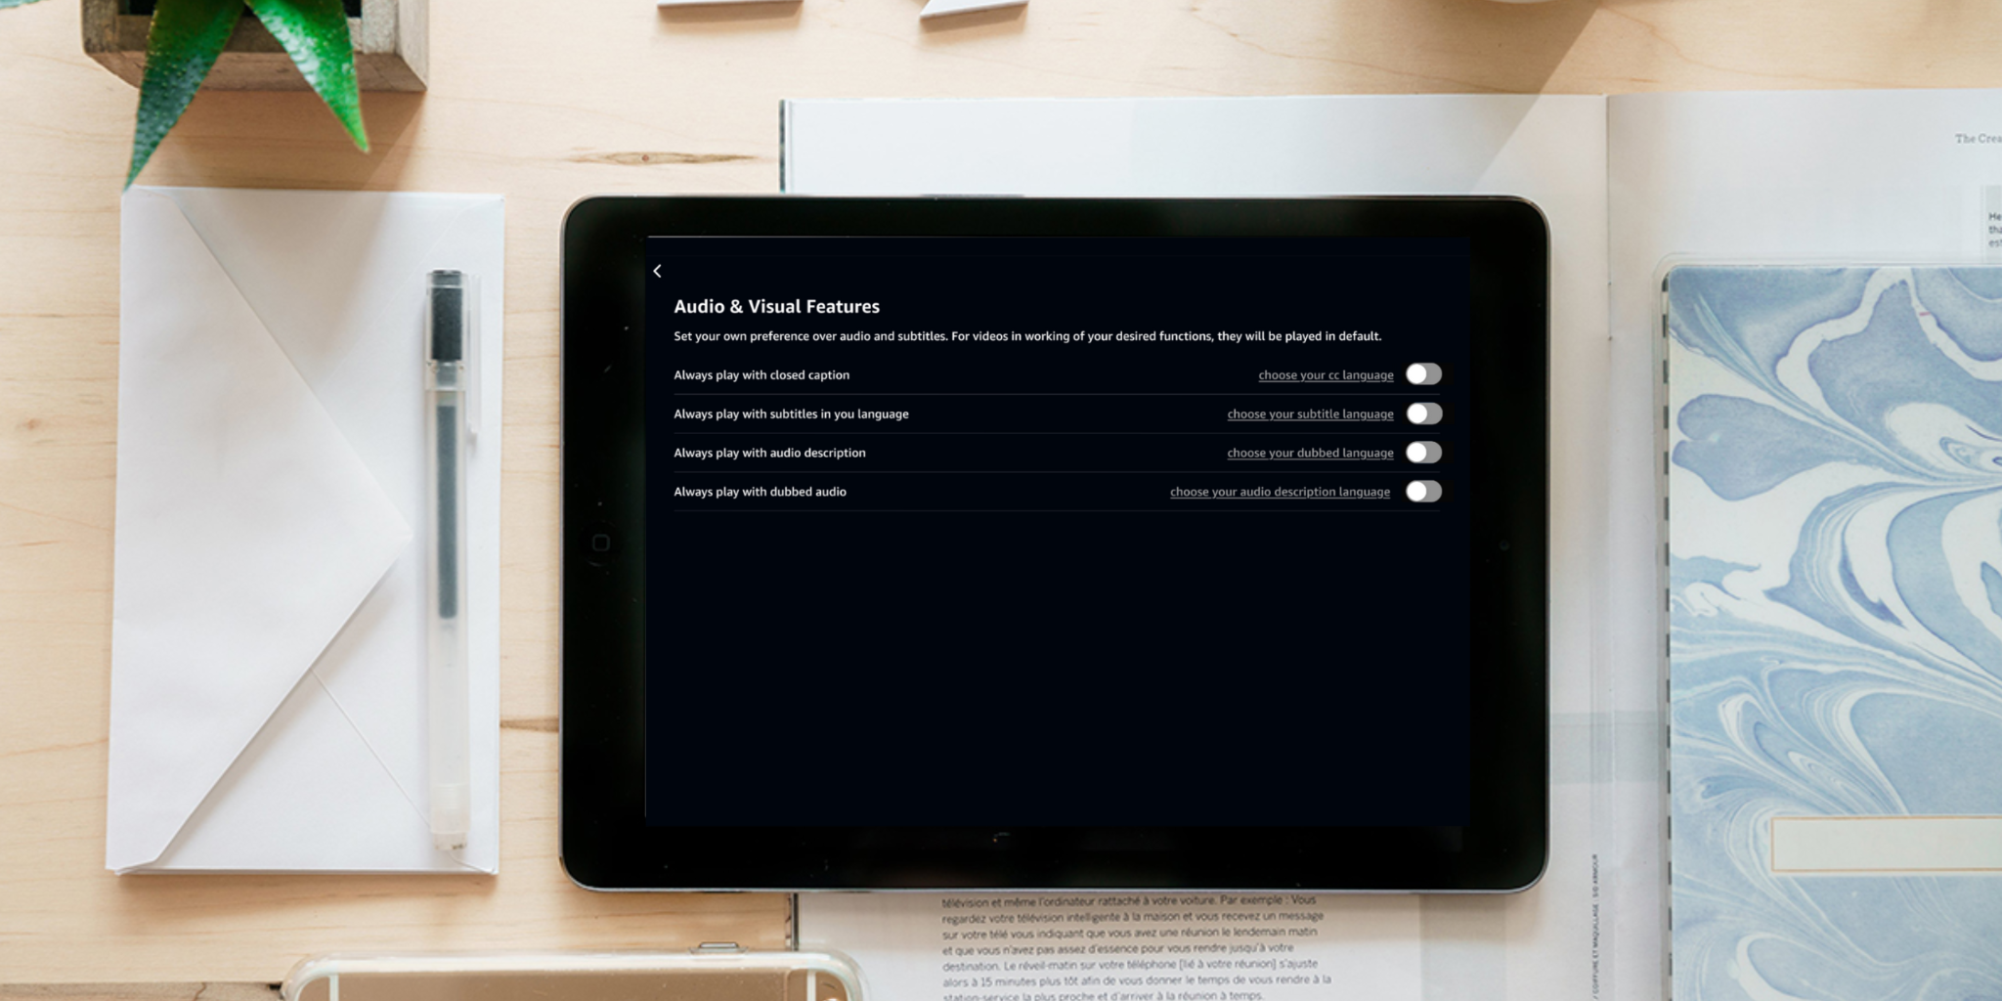

10, I think it will be very helpful and save a lot of time from having to check each movie or show I select.

1. **Thinking of the times when you want to watch media based on your mood, how would having a much faster and easier way to filter the content of a certain tab be? This way, you wouldn’t have to permanently set a specific filter but still have the option at hand. (Please rate on a scale of one to ten with ten being easy to access)**

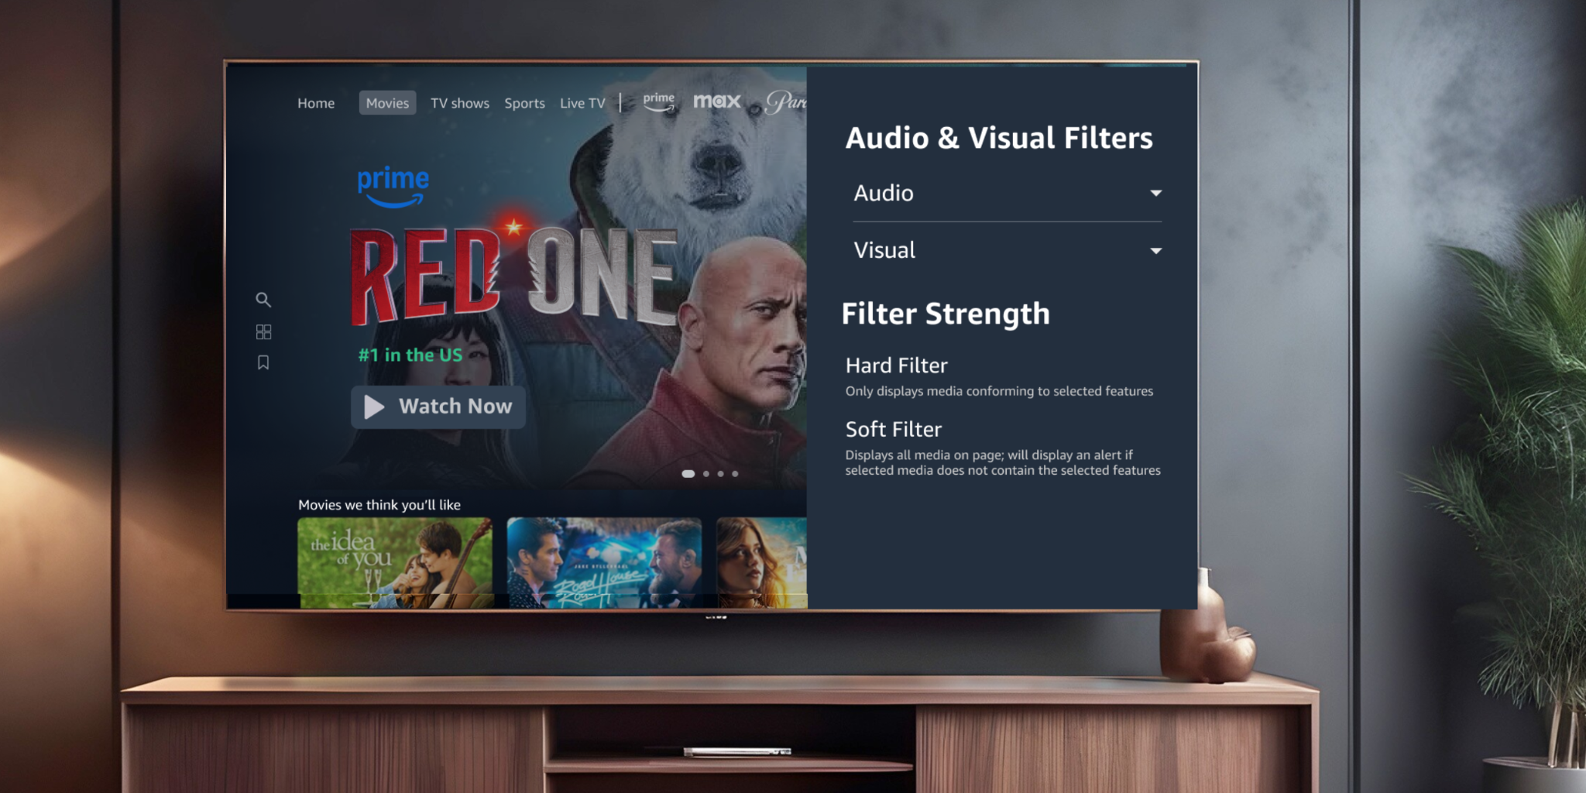

10, this would be very helpful.

1. **What about having a similar filter when you’re using the search page? (Please rate on a scale of one to ten with ten being easy to access)**

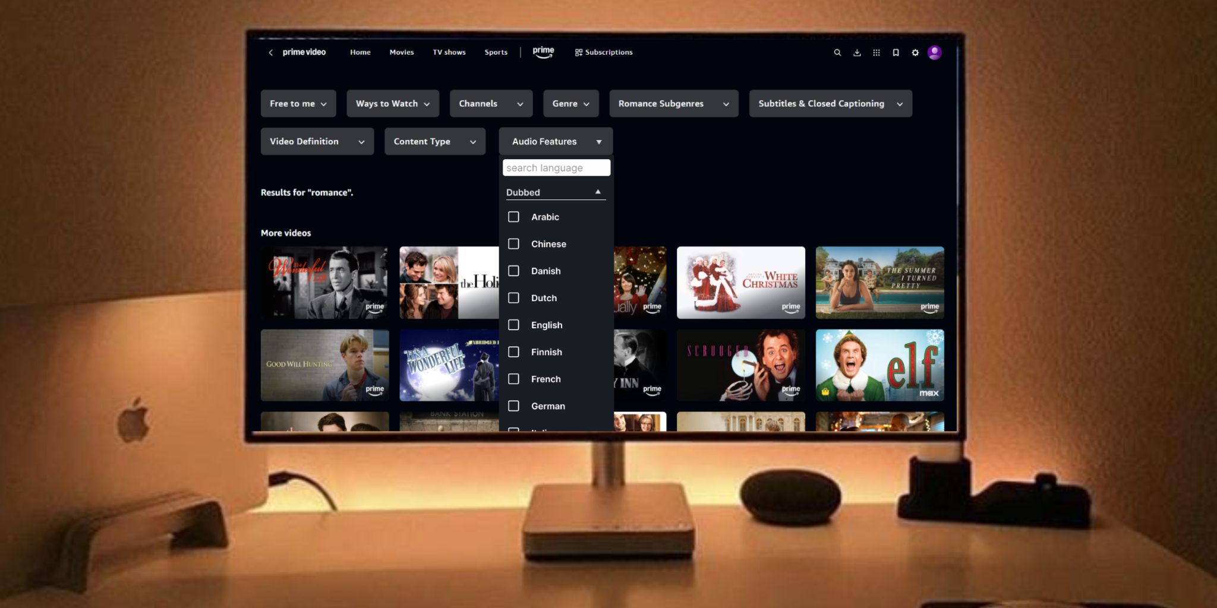

10

1. **What is one feature that you would like to have on Prime Video to improve the app’s accessibility as a user for the dubbed filter feature?**

I can’t think of anything right now but I would say having an easier way to access the feature once I play the movie would be helpful instead of the tiny icons.

### Subtitles

1. **How often do you watch videos on Prime video with subtitles? (On a scale of one to ten with ten being all the time)?**
2. **Do subtitles enhance your viewing experience on Prime Video?**
3. **How would you rate the ease of changing subtitles on Prime Video? (Please rate on a scale of one to ten with ten being easy to access)**
4. **On a scale of 1-10, how helpful would saving subtitle preferences to your profile be? This would give you the ability to have all your content be filtered throughout the app to your preferences. You can have the ability to set how filtered the content should be. (Please rate on a scale of one to ten with ten being very helpful)**



1. **Thinking of the times when you want to watch media based on your mood, how would having a much faster and easier way to filter the content of a certain tab be? This way, you wouldn’t have to permanently set a specific filter but still have the option at hand. (Please rate on a scale of one to ten with ten being helpful)**



1. **What about having a similar filter when you’re using the search page? (Please rate on a scale of one to ten with ten being easy to access)**



1. **Would these filters help you search for media with your preferred subtitle language? (Yes/No)**
2. **What is one feature that you would like to have on Prime Video to improve the app’s accessibility as a user for the subtitle filter/feature?**

### Subtitles – Tanya

1. **How often do you watch videos on Prime video with subtitles? (On a scale of one to ten with ten being all the time)?**

10

1. **Would you prefer having a filter to help you search for media with your preferred subtitle language? (Yes/No)**

Yes

1. **Do subtitles enhance your viewing experience on Prime Video?**

Certainly. Most of the movies I watch are in English, but I have trouble understanding British accents. Hence, subtitles are an absolute must for me. Even for movies not in English, subtitles help me a lot.

1. **How would you rate the ease of changing subtitles on Prime Video? (Please rate on a scale of one to ten with ten being easy to access)**

7. It’s easy to change it with the button, but once changed, the device takes quite a bit of time to sync properly

1. **On a scale of 1-10, how helpful would saving subtitle preferences to your profile be? This would give you the ability to have all your content be filtered throughout the app to your preferences. You can have the ability to set how filtered the content should be.**

8. It’s not a big problem for me currently, but that sounds helpful in curating the content I would be recommended.

1. **Thinking of the times when you want to watch media based on your mood, how would having a much faster and easier way to filter the content of a certain tab be? This way, you wouldn’t have to permanently set a specific filter but still have the option at hand. (Please rate on a scale of one to ten with ten being easy to access)**

9

1. **What about having a similar filter when you’re using the search page? (Please rate on a scale of one to ten with ten being easy to access)**

10